**NAME: Muhammad Zafar Ul Haq**

**DATABASE LAB PROJECT**

(HOSPITAL MANAGEMENT SYSTEM)

**COMPLETE PROJECT**

**TABLES:**

CREATE DATABASE HMS;

USE HMS;

-- Patient Table

CREATE TABLE Patient(

email varchar(50) PRIMARY KEY,

password varchar(30) NOT NULL,

name varchar(50) NOT NULL,

address varchar(60) NOT NULL,

gender VARCHAR(20) NOT NULL

);

INSERT INTO Patient (email, password, name, address, gender) VALUES

('john.doe@example.com', 'password123', 'John Doe', '123 Main St, Cityville', 'Male'),

('jane.smith@example.com', 'password456', 'Jane Smith', '456 Elm St, Townsville', 'Female'),

('alice.johnson@example.com', 'password789', 'Alice Johnson', '789 Oak St, Villagetown', 'Female'),

('michael.brown@example.com', 'password111', 'Michael Brown', '321 Pine St, Cityville', 'Male'),

('linda.williams@example.com', 'password222', 'Linda Williams', '654 Cedar St, Townsville', 'Female'),

('david.miller@example.com', 'password333', 'David Miller', '987 Birch St, Villagetown', 'Male'),

('susan.davis@example.com', 'password444', 'Susan Davis', '111 Maple St, Cityville', 'Female'),

('robert.garcia@example.com', 'password555', 'Robert Garcia', '222 Walnut St, Townsville', 'Male'),

('lisa.martinez@example.com', 'password666', 'Lisa Martinez', '333 Chestnut St, Villagetown', 'Female'),

('james.lee@example.com', 'password777', 'James Lee', '444 Spruce St, Cityville', 'Male');

-- MedicalHistory Table

CREATE TABLE MedicalHistory(

id int PRIMARY KEY,

date DATE NOT NULL,

conditions VARCHAR(100) NOT NULL,

surgeries VARCHAR(100) NOT NULL,

medication VARCHAR(100) NOT NULL

);

INSERT INTO MedicalHistory (id, date, conditions, surgeries, medication) VALUES

(1, '2023-01-10', 'Hypertension', 'Appendectomy', 'Lisinopril'),

(2, '2023-02-20', 'Diabetes', 'None', 'Metformin'),

(3, '2023-03-15', 'Asthma', 'None', 'Albuterol'),

(4, '2023-04-25', 'Hyperthyroidism', 'Thyroidectomy', 'Levothyroxine'),

(5, '2023-05-10', 'Arthritis', 'None', 'Ibuprofen'),

(6, '2023-06-20', 'Depression', 'None', 'Sertraline'),

(7, '2023-07-15', 'High Cholesterol', 'None', 'Atorvastatin'),

(8, '2023-08-10', 'GERD', 'None', 'Omeprazole'),

(9, '2023-09-05', 'Anemia', 'None', 'Ferrous Sulfate'),

(10, '2023-10-01', 'COPD', 'None', 'Fluticasone');

-- Doctor Table

CREATE TABLE Doctor(

email varchar(50) PRIMARY KEY,

gender varchar(20) NOT NULL,

password varchar(30) NOT NULL,

name varchar(50) NOT NULL

);

INSERT INTO Doctor (email, gender, password, name) VALUES

('dr.smith@example.com', 'Male', 'docpassword123', 'Dr. John Smith'),

('dr.jones@example.com', 'Female', 'docpassword456', 'Dr. Emily Jones'),

('dr.wilson@example.com', 'Male', 'docpassword789', 'Dr. Robert Wilson'),

('dr.lee@example.com', 'Female', 'docpassword234', 'Dr. Lisa Lee'),

('dr.clark@example.com', 'Male', 'docpassword345', 'Dr. David Clark'),

('dr.lopez@example.com', 'Female', 'docpassword456', 'Dr. Maria Lopez'),

('dr.davis@example.com', 'Male', 'docpassword567', 'Dr. James Davis'),

('dr.thompson@example.com', 'Female', 'docpassword678', 'Dr. Karen Thompson'),

('dr.brown@example.com', 'Male', 'docpassword789', 'Dr. Michael Brown'),

('dr.martin@example.com', 'Female', 'docpassword890', 'Dr. Susan Martin');

-- Appointment Table

CREATE TABLE Appointment(

id int PRIMARY KEY,

date DATE NOT NULL,

starttime TIME NOT NULL,

endtime TIME NOT NULL,

status varchar(15) NOT NULL

);

INSERT INTO Appointment (id, date, starttime, endtime, status) VALUES

(1, '2024-06-10', '09:00:00', '09:30:00', 'Scheduled'),

(2, '2024-06-11', '10:00:00', '10:30:00', 'Completed'),

(3, '2024-06-12', '11:00:00', '11:30:00', 'Cancelled'),

(4, '2024-06-13', '12:00:00', '12:30:00', 'Scheduled'),

(5, '2024-06-14', '13:00:00', '13:30:00', 'Completed'),

(6, '2024-06-15', '14:00:00', '14:30:00', 'Cancelled'),

(7, '2024-06-16', '15:00:00', '15:30:00', 'Scheduled'),

(8, '2024-06-17', '16:00:00', '16:30:00', 'Completed'),

(9, '2024-06-18', '17:00:00', '17:30:00', 'Cancelled'),

(10, '2024-06-19', '18:00:00', '18:30:00', 'Scheduled');

-- PatientsAttendAppointments Table

CREATE TABLE PatientsAttendAppointments(

patient varchar(50) NOT NULL,

appt int NOT NULL,

concerns varchar(40) NOT NULL,

symptoms varchar(40) NOT NULL,

FOREIGN KEY (patient) REFERENCES Patient (email) ON DELETE CASCADE,

FOREIGN KEY (appt) REFERENCES Appointment (id) ON DELETE CASCADE,

PRIMARY KEY (patient, appt)

);

INSERT INTO PatientsAttendAppointments (patient, appt, concerns, symptoms) VALUES

('john.doe@example.com', 1, 'Chest pain', 'Shortness of breath'),

('jane.smith@example.com', 2, 'Headache', 'Fever'),

('alice.johnson@example.com', 3, 'Back pain', 'Nausea'),

('michael.brown@example.com', 4, 'Knee pain', 'Swelling'),

('linda.williams@example.com', 5, 'Sore throat', 'Cough'),

('david.miller@example.com', 6, 'Dizziness', 'Fatigue'),

('susan.davis@example.com', 7, 'Abdominal pain', 'Bloating'),

('robert.garcia@example.com', 8, 'Skin rash', 'Itching'),

('lisa.martinez@example.com', 9, 'Earache', 'Hearing loss'),

('james.lee@example.com', 10, 'Toothache', 'Swelling');

-- Schedule Table

CREATE TABLE Schedule(

id int NOT NULL,

starttime TIME NOT NULL,

endtime TIME NOT NULL,

breaktime TIME NOT NULL,

day varchar(20) NOT NULL,

PRIMARY KEY (id, starttime, endtime, breaktime, day)

);

INSERT INTO Schedule (id, starttime, endtime, breaktime, day) VALUES

(1, '09:00:00', '17:00:00', '12:00:00', 'Monday'),

(2, '09:00:00', '17:00:00', '12:00:00', 'Tuesday'),

(3, '09:00:00', '17:00:00', '12:00:00', 'Wednesday'),

(4, '09:00:00', '17:00:00', '12:00:00', 'Thursday'),

(5, '09:00:00', '17:00:00', '12:00:00', 'Friday'),

(6, '10:00:00', '18:00:00', '13:00:00', 'Monday'),

(7, '10:00:00', '18:00:00', '13:00:00', 'Tuesday'),

(8, '10:00:00', '18:00:00', '13:00:00', 'Wednesday'),

(9, '10:00:00', '18:00:00', '13:00:00', 'Thursday'),

(10, '10:00:00', '18:00:00', '13:00:00', 'Friday');

-- PatientsFillHistory Table

CREATE TABLE PatientsFillHistory(

patient varchar(50) NOT NULL,

history int NOT NULL,

FOREIGN KEY (patient) REFERENCES Patient (email) ON DELETE CASCADE,

FOREIGN KEY (history) REFERENCES MedicalHistory (id) ON DELETE CASCADE,

PRIMARY KEY (history)

);

INSERT INTO PatientsFillHistory (patient, history) VALUES

('john.doe@example.com', 1),

('jane.smith@example.com', 2),

('alice.johnson@example.com', 3),

('michael.brown@example.com', 4),

('linda.williams@example.com', 5),

('david.miller@example.com', 6),

('susan.davis@example.com', 7),

('robert.garcia@example.com', 8),

('lisa.martinez@example.com', 9),

('james.lee@example.com', 10);

-- Diagnose Table

CREATE TABLE Diagnose(

appt int NOT NULL,

doctor varchar(50) NOT NULL,

diagnosis varchar(40) NOT NULL,

prescription varchar(50) NOT NULL,

FOREIGN KEY (appt) REFERENCES Appointment (id) ON DELETE CASCADE,

FOREIGN KEY (doctor) REFERENCES Doctor (email) ON DELETE CASCADE,

PRIMARY KEY (appt, doctor)

);

INSERT INTO Diagnose (appt, doctor, diagnosis, prescription) VALUES

(1, 'dr.smith@example.com', 'Bronchitis', 'Amoxicillin'),

(2, 'dr.jones@example.com', 'Migraine', 'Ibuprofen'),

(3, 'dr.wilson@example.com', 'Muscle strain', 'Paracetamol'),

(4, 'dr.lee@example.com', 'Arthritis', 'Celecoxib'),

(5, 'dr.clark@example.com', 'Sinusitis', 'Doxycycline'),

(6, 'dr.lopez@example.com', 'Gastritis', 'Pantoprazole'),

(7, 'dr.davis@example.com', 'Allergic rhinitis', 'Cetirizine'),

(8, 'dr.thompson@example.com', 'Osteoporosis', 'Alendronate'),

(9, 'dr.brown@example.com', 'Conjunctivitis', 'Ofloxacin'),

(10, 'dr.martin@example.com', 'UTI', 'Nitrofurantoin');

-- DocsHaveSchedules Table

CREATE TABLE DocsHaveSchedules(

sched int NOT NULL,

doctor varchar(50) NOT NULL,

FOREIGN KEY (sched) REFERENCES Schedule (id) ON DELETE CASCADE,

FOREIGN KEY (doctor) REFERENCES Doctor (email) ON DELETE CASCADE,

PRIMARY KEY (sched, doctor)

);

INSERT INTO DocsHaveSchedules (sched, doctor) VALUES

(1, 'dr.smith@example.com'),

(2, 'dr.jones@example.com'),

(3, 'dr.wilson@example.com'),

(4, 'dr.lee@example.com'),

(5, 'dr.clark@example.com'),

(6, 'dr.lopez@example.com'),

(7, 'dr.davis@example.com'),

(8, 'dr.thompson@example.com'),

(9, 'dr.brown@example.com'),

(10, 'dr.martin@example.com');

-- DoctorViewsHistory Table

CREATE TABLE DoctorViewsHistory(

history int NOT NULL,

doctor varchar(50) NOT NULL,

FOREIGN KEY (doctor) REFERENCES Doctor (email) ON DELETE CASCADE,

FOREIGN KEY (history) REFERENCES MedicalHistory (id) ON DELETE CASCADE,

PRIMARY KEY (history, doctor)

);

INSERT INTO DoctorViewsHistory (history, doctor) VALUES

(1, 'dr.smith@example.com'),

(2, 'dr.jones@example.com'),

(3, 'dr.wilson@example.com'),

(4, 'dr.lee@example.com'),

(5, 'dr.clark@example.com'),

(6, 'dr.lopez@example.com'),

(7, 'dr.davis@example.com'),

(8, 'dr.thompson@example.com'),

(9, 'dr.brown@example.com'),

(10, 'dr.martin@example.com');

**JOIN QUERIES:**

**10 Queries**

1. **Get Patient Details with Their Medical History**

SELECT

Patient.email,

Patient.name,

Patient.gender,

MedicalHistory.conditions,

MedicalHistory.surgeries,

MedicalHistory.medication

FROM

Patient

JOIN

PatientsFillHistory ON Patient.email = PatientsFillHistory.patient

JOIN

MedicalHistory ON PatientsFillHistory.history = MedicalHistory.id; 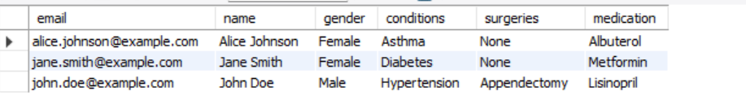

1. **Get Appointments with Patient and Doctor Details**

**SELECT**

**Appointment.id AS AppointmentID,**

**Appointment.date AS AppointmentDate,**

**Appointment.starttime AS StartTime,**

**Appointment.endtime AS EndTime,**

**Appointment.status AS Status,**

**Patient.name AS PatientName,**

**Patient.gender AS PatientGender,**

**PatientsAttendAppointments.concerns,**

**PatientsAttendAppointments.symptoms,**

**Doctor.name AS DoctorName,**

**Diagnose.diagnosis,**

**Diagnose.prescription**

**FROM**

**Appointment**

**JOIN**

**PatientsAttendAppointments ON Appointment.id = PatientsAttendAppointments.appt**

**JOIN**

**Patient ON PatientsAttendAppointments.patient = Patient.email**

**JOIN**

**Diagnose ON Appointment.id = Diagnose.appt**

**JOIN**

**Doctor ON Diagnose.doctor = Doctor.email;**

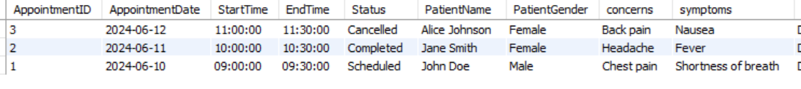

1. **Get Doctor's Schedules with Associated Appointments**

SELECT

Doctor.name AS DoctorName,

Schedule.day AS Day,

Schedule.starttime AS ScheduleStartTime,

Schedule.endtime AS ScheduleEndTime,

Schedule.breaktime AS BreakTime,

Appointment.id AS AppointmentID,

Appointment.date AS AppointmentDate,

Appointment.starttime AS AppointmentStartTime,

Appointment.endtime AS AppointmentEndTime,

Appointment.status AS Status

FROM

Doctor

JOIN

DocsHaveSchedules ON Doctor.email = DocsHaveSchedules.doctor

JOIN

Schedule ON DocsHaveSchedules.sched = Schedule.id

LEFT JOIN

Diagnose ON Doctor.email = Diagnose.doctor

LEFT JOIN

Appointment ON Diagnose.appt = Appointment.id; 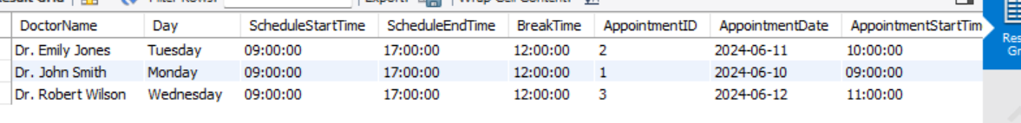

1. **Find Patients Diagnosed by a Specific Doctor**

SELECT

Doctor.name AS DoctorName,

Patient.name AS PatientName,

Patient.email AS PatientEmail,

Diagnose.diagnosis,

Diagnose.prescription

FROM

Doctor

JOIN

Diagnose ON Doctor.email = Diagnose.doctor

JOIN

PatientsAttendAppointments ON Diagnose.appt = PatientsAttendAppointments.appt

JOIN

Patient ON PatientsAttendAppointments.patient = Patient.email

WHERE

Doctor.name = 'Dr. John Smith'; -- Replace with the desired doctor's name



1. **Get Detailed Medical History Viewed by Doctors**

SELECT

Doctor.name AS DoctorName,

MedicalHistory.id AS MedicalHistoryID,

MedicalHistory.conditions,

MedicalHistory.surgeries,

MedicalHistory.medication,

MedicalHistory.date AS HistoryDate

FROM

Doctor

JOIN

DoctorViewsHistory ON Doctor.email = DoctorViewsHistory.doctor

JOIN

MedicalHistory ON DoctorViewsHistory.history = MedicalHistory.id; 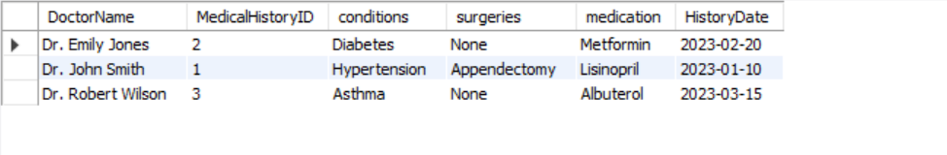

1. **Find Appointments with Patients and Doctors' Names**

SELECT

Appointment.id AS AppointmentID,

Appointment.date AS AppointmentDate,

Patient.name AS PatientName,

Doctor.name AS DoctorName,

Appointment.status AS Status

FROM

Appointment

JOIN

PatientsAttendAppointments ON Appointment.id = PatientsAttendAppointments.appt

JOIN

Patient ON PatientsAttendAppointments.patient = Patient.email

JOIN

Diagnose ON Appointment.id = Diagnose.appt

JOIN

Doctor ON Diagnose.doctor = Doctor.email; 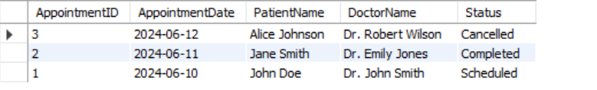

1. **Get Patients' Contact Information for Their Appointments**

SELECT

Patient.name AS PatientName,

Patient.email AS PatientEmail,

Patient.address AS PatientAddress,

Appointment.date AS AppointmentDate,

Appointment.starttime AS StartTime,

Appointment.endtime AS EndTime,

Appointment.status AS Status

FROM

Patient

JOIN

PatientsAttendAppointments ON Patient.email = PatientsAttendAppointments.patient

JOIN

Appointment ON PatientsAttendAppointments.appt = Appointment.id

WHERE

Appointment.status = 'Scheduled'; 

1. **Doctors' Availability for Specific Days**

SELECT

Doctor.name AS DoctorName,

Schedule.day AS Day,

Schedule.starttime AS StartTime,

Schedule.endtime AS EndTime,

Schedule.breaktime AS BreakTime

FROM

Doctor

JOIN

DocsHaveSchedules ON Doctor.email = DocsHaveSchedules.doctor

JOIN

Schedule ON DocsHaveSchedules.sched = Schedule.id

WHERE

Schedule.day = 'Monday'; -- Replace with the desired day 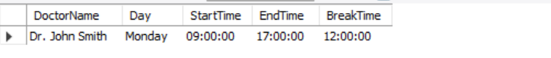

1. **Doctors with Their Specialization in Viewing Medical Histories**

SELECT

Doctor.name AS DoctorName,

MedicalHistory.conditions AS Specialization

FROM

Doctor

JOIN

DoctorViewsHistory ON Doctor.email = DoctorViewsHistory.doctor

JOIN

MedicalHistory ON DoctorViewsHistory.history = MedicalHistory.id

ORDER BY

Doctor.name; 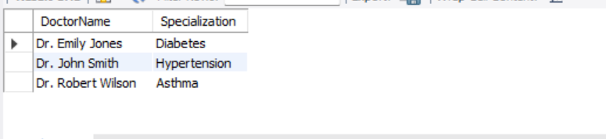

1. **Patients' Concerns and Symptoms During Their Appointments**

SELECT

Patient.name AS PatientName,

Appointment.date AS AppointmentDate,

PatientsAttendAppointments.concerns,

PatientsAttendAppointments.symptoms

FROM

Patient

JOIN

PatientsAttendAppointments ON Patient.email = PatientsAttendAppointments.patient

JOIN

Appointment ON PatientsAttendAppointments.appt = Appointment.id; 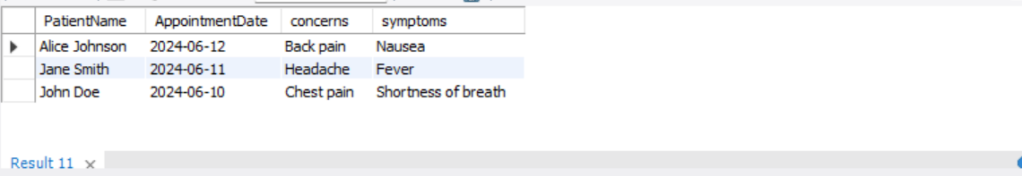

**NESTED QUERIES:**

**1.**SELECT

p.name,

d.diagnosis,

(SELECT doc.name FROM Doctor doc WHERE doc.email = d.doctor) AS doctor_name

FROM Patient p

JOIN PatientsAttendAppointments paa ON p.email = paa.patient

JOIN Diagnose d ON paa.appt = d.appt;

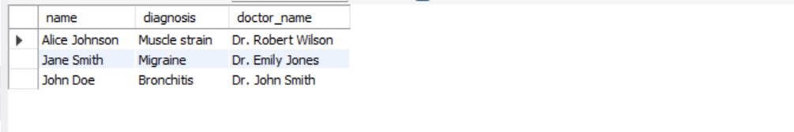

**2.** SELECT

p.name,

paa.symptoms,

(SELECT d.diagnosis FROM Diagnose d WHERE d.appt = a.id) AS diagnosis

FROM Appointment a

JOIN PatientsAttendAppointments paa ON a.id = paa.appt

JOIN Patient p ON paa.patient = p.email

WHERE a.date = '2024-06-10';3.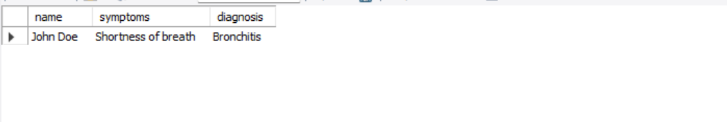

**3.** SELECT

p.name,

mh.date,

(SELECT doc.name FROM Doctor doc JOIN DoctorViewsHistory dvh ON doc.email = dvh.doctor WHERE dvh.history = mh.id) AS doctor_name

FROM MedicalHistory mh

JOIN PatientsFillHistory pfh ON mh.id = pfh.history

JOIN Patient p ON pfh.patient = p.email;

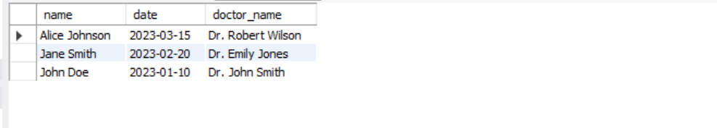

**4.** SELECT

p.name,

paa.concerns

FROM Patient p

JOIN (SELECT paa.patient, paa.concerns FROM Appointment a JOIN PatientsAttendAppointments paa ON a.id = paa.appt WHERE a.status = 'Scheduled') paa

ON p.email = paa.patient;

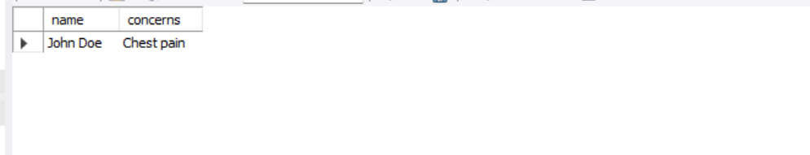

**5.** SELECT

s.day,

s.starttime,

s.endtime,

(SELECT a.status FROM Appointment a WHERE a.id = s.id) AS appointment_status

FROM Schedule s

JOIN DocsHaveSchedules dhs ON s.id = dhs.sched

WHERE dhs.doctor = 'dr.smith@example.com'; 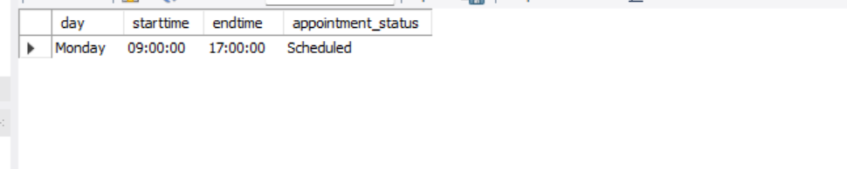

**6.** SELECT

p.name

FROM Patient p

WHERE NOT EXISTS (

SELECT 1 FROM Diagnose d JOIN PatientsAttendAppointments paa ON d.appt = paa.appt WHERE paa.patient = p.email

);

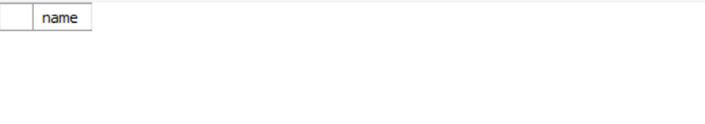

**7.** SELECT

a.date,

(SELECT d.diagnosis FROM Diagnose d WHERE d.appt = paa.appt) AS last_diagnosis

FROM Appointment a

JOIN PatientsAttendAppointments paa ON a.id = paa.appt

WHERE paa.patient = 'john.doe@example.com' AND a.status = 'Scheduled'; 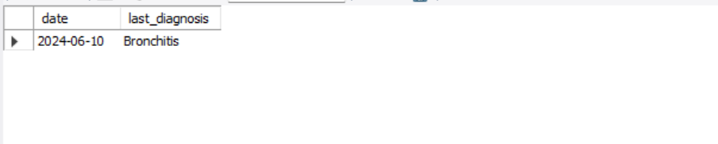

**8.** SELECT

d.name AS doctor_name,

(SELECT p.name

FROM PatientsAttendAppointments paa

JOIN Patient p ON paa.patient = p.email

JOIN Appointment a ON paa.appt = a.id

WHERE a.id = (SELECT MIN(appt)

FROM Diagnose diag

WHERE diag.doctor = d.email)) AS next_patient

FROM Doctor d; 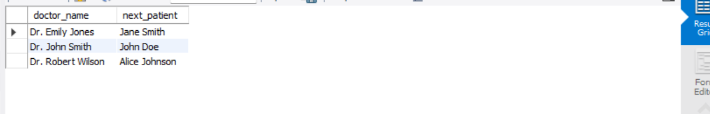

**9.** SELECT

p.name,

p.address,

p.gender,

(SELECT d.diagnosis

FROM Diagnose d

JOIN PatientsAttendAppointments paa ON d.appt = paa.appt

WHERE paa.patient = p.email

ORDER BY d.appt DESC

LIMIT 1) AS recent_diagnosis

FROM Patient p; 